East Morgan County Library 1,000 Books Before Kindergarten Program
Our Process:
- Fill out form, take picture, give reading card.
- For every card of 100 turned in, child receives prize and another picture is taken.
- Displayed on wall with “book” labeled with level and date.
- When all ten levels are turned in, we have a party and present family with a scrapbook of all the pictures of the child.
- Repetition is encouraged. If a book is read more than once, count it each time!

East Morgan County Library
1,000 Books Before
Kindergarten

Child’s Name
Parent’s Name
Child’s Date of Birth Age at Sign-up
Address
Phone Number

Level 1
1,000 Books Before Kindergarten!
Name __________________

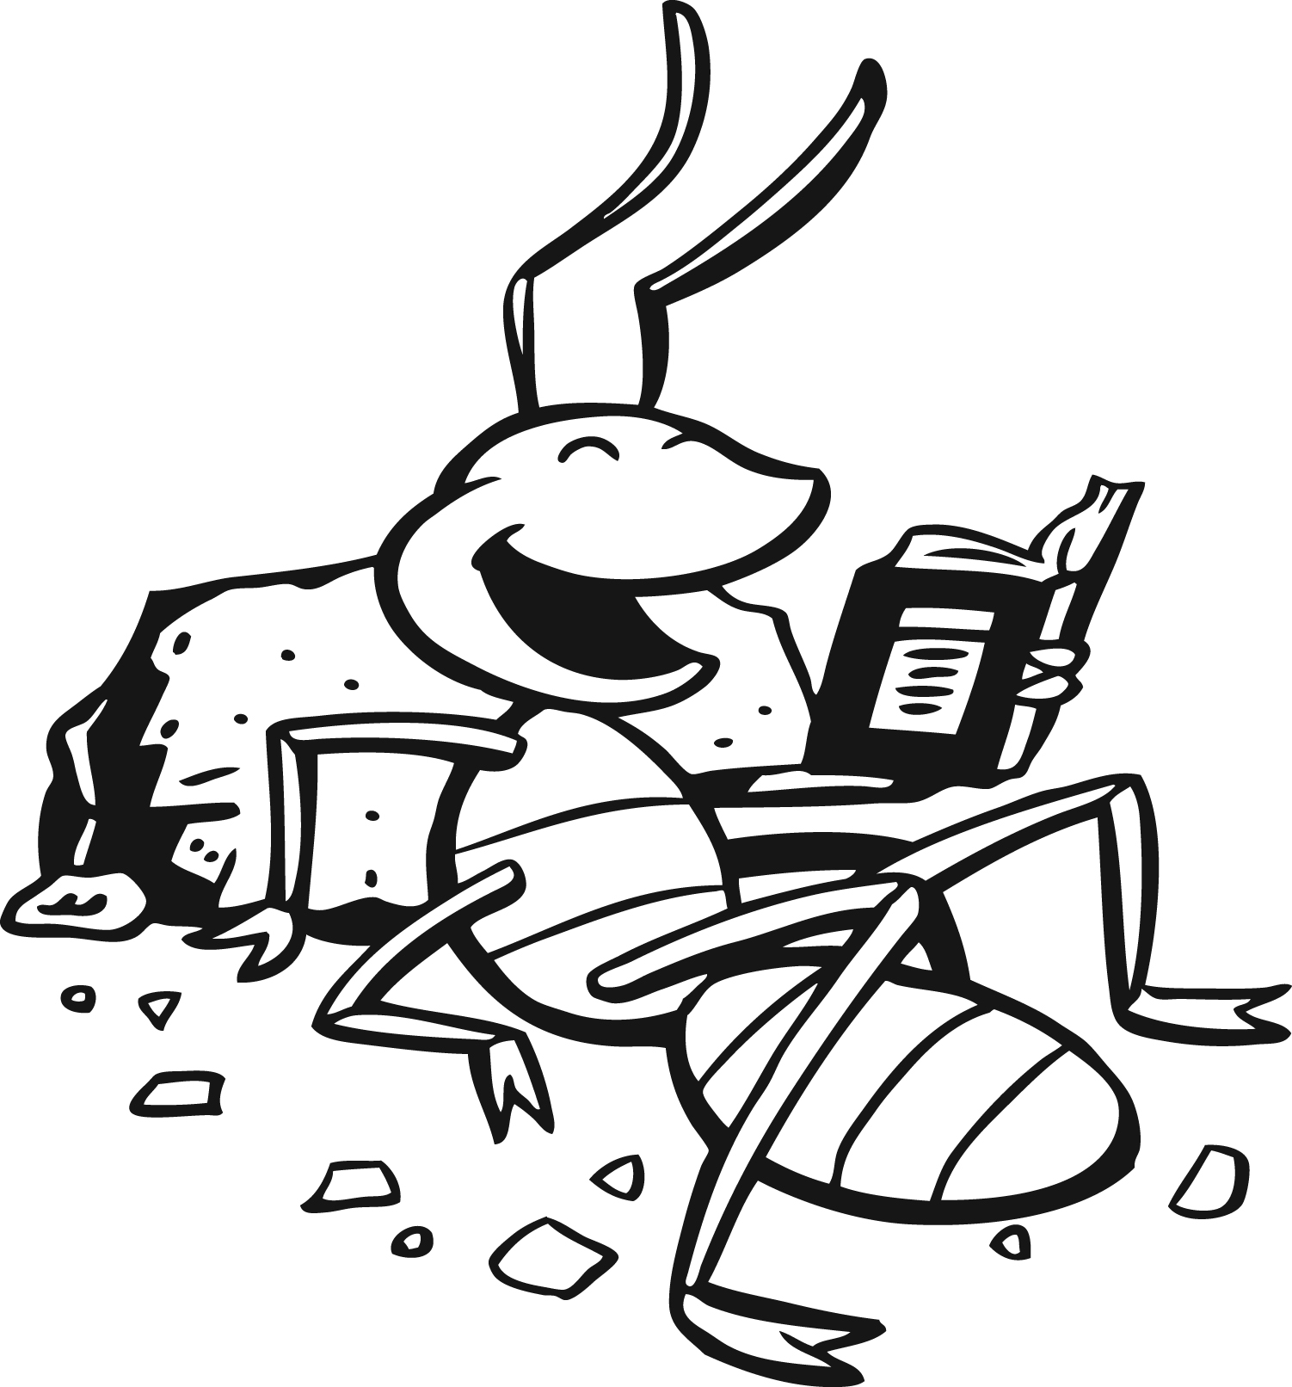

Level 1
1,000 Books Before Kindergarten!
Name __________________

Level 1
1,000 Books Before Kindergarten!
Name __________________

Level 1
1,000 Books Before Kindergarten!
Name __________________

EMCL – Level 1
1,000 Books Before Kindergarten!
Name __________________
For every book you read to your child, cross off a picture – front and back. When they are all crossed off turn them in for a prize!

EMCL – Level 1
1,000 Books Before Kindergarten!
Name __________________
For every book you read to your child, cross off a picture – front and back. When they are all crossed off turn them in for a prize!

EMCL – Level 1
1,000 Books Before Kindergarten!
Name __________________
For every book you read to your child, cross off a picture – front and back. When they are all crossed off turn them in for a prize!

EMCL – Level 1
1,000 Books Before Kindergarten!
Name __________________
For every book you read to your child, cross off a picture – front and back. When they are all crossed off turn them in for a prize!

